**EDUBOT: AUTOMATED SUPPORT TICKET MANAGEMENT FOR EDUCATIONAL INSTITUTIONS**

**A PROJECT REPORT**

***Submitted by***

**KARISHMA KANNADASAN (210701106)**

***in partial fulfillment for the course***

### CS19P21 - ADVANCED ROBOTIC PROCESS AUTOMATION

***for the award of the degree of***

**BACHELOR OF ENGINEERING**

**IN**

**COMPUTER SCIENCE AND ENGINEERING**

**NOVEMBER 2024**

#### BONAFIDE CERTIFICATE

Certified that this project **“EDUBOT:AUTOMATED SUPPORT TICKET MANAGEMENT FOR EDUCATIONAL INSTITUTION”**

is the bonafide work of **“KARISHMA KANNADASAN –210701106”** who carried out the project work under my supervision.

**SIGNATURE**

**Dr. P. KUMAR**

**HEAD OF THE DEPARTMENT**

Professor and Head

Dept. of Computer Science and

Engg,

Rajalakshmi Engineering College Chennai.

**EXTERNAL EXAMINER**

**SIGNATURE**

**Mr. B. BHUVANESWARAN, M.E.,**

**SUPERVISOR**

Assistant Professor (SG)

Dept. of Computer Science and

Engg,

Rajalakshmi Engineering College Chennai.

**INTERNAL EXAMINER**

#### ABSTRACT

The management of support tickets in educational institutions is often hindered by inefficiencies such as lack of prioritization, delayed routing, and inconsistent resolution timelines. This results in frustration among students, faculty, and staff. To address these challenges, this project develops an AI-powered system that classifies and prioritizes tickets using a text classification model in AI Center. Tickets are categorized as High, Medium, or Low priority and routed to appropriate departments using UiPath Studio. Email notifications and Excel automation streamline the workflow, while a tracking dashboard monitors response times. This system improves operational efficiency, reduces delays, and enhances user satisfaction through faster and more accurate ticket handling.

**ACKNOWLEDGEMENT**

Initially we thank the Almighty for being with us through every walk of our life and showering his blessings through the endeavor to put forth this report. Our sincere thanks to our Chairman **Mr. S.Meganathan, B.E, F.I.E.,** our Vice Chairman **Mr. Abhay Shankar Meganathan, B.E., M.S.,** and our respected Chairperson **Dr. (Mrs.) Thangam Meganathan, Ph.D.,** for providing us with the requisite infrastructure and sincere endeavoring in educating us in their premier institution.

Our sincere thanks to **Dr. S.N.Murugesan, M.E., Ph.D.,** our beloved Principal for his kind support and facilities provided to complete our work in time. We express our sincere thanks to **Dr. P.Kumar, M.E., Ph.D.,** Professor and Head of the Department of Computer Science and Engineering for his guidance and encouragement throughout the project work. We convey our sincere and deepest gratitude to our internal guide, **Dr. N.Durai Murugan, M.E., Ph.D.,** Associate Professor, Department of Computer Science and Engineering, Rajalakshmi Engineering College for their valuable guidance throughout the course of the project. We are very glad to thank our Project Coordinator and Supervisor, and **Mr.B.Bhuvaneswaran, M.E.,** Assistant Professor (SG), Department of Computer Science and Engineering and **Ms.J.Jinu Sophia ,** Assistant Professor for their useful tips during our review to build our project.

**KARISHMA KANNADASAN (210701106)**

**TABLE OF CONTENTS**

|  |  |  |  |
| --- | --- | --- | --- |
| **CHAPTER NO.** | **TITLE** | **PAGE NO.** | |
|  | **ACKNOWLEDGEMENT** | **iv** | |
|  | **ABSTRACT** | **iii** | |
|  | **LIST OF FIGURES** | **vii** | |
|  | **LIST OF ABBREVIATIONS** | **viii** | |
| **1.** | **INTRODUCTION** | **1** | |
|  | 1.1 DESCRIPTION | 1 | |
|  | 1.2 SCOPE OF WORK 1  1.3 PROBLEM STATEMENT 2 | |
|  | 1.4 AIM AND OBLECTIVE 2  1.5 EXISTING SYSTEM 3 | |
|  | 1.6 PROPOSED SYSTEM 3 | |
| **2.** | **LITERATURE SURVEY** | **5** | |
| **3.** | **SYSTEM DESIGN** | **7** | |
|  | 3.1 GENERAL | 7 | |
|  | 3.1.1 SYSTEM FLOW DIAGRAM | 7 | |
|  | 3.1.2 ARCHITECTURE DIAGRAM | 8 | |
|  | 3.1.3 SEQUENCE DIAGRAM | 9 | |
|  |

|  |  |  |
| --- | --- | --- |
| **4.** | **PROJECT DESCRIPTION** | **10** |
|  | 4.1 MODULES DESCRIPTION | 11 |
| **5.** | **PROJECT OVERVIEW** | **12** |
|  | 5.1 IMPLEMENTATION | 12 |
|  | 5.2 OUTPUT SCREENSHOTS | 19 |
| **6.** | **CONCLUSION AND FUTURE ENHANCEMENT** | **20** |
|  | 6.1 CONCLUSION | 20 |
|  | 6.2 WORK SCHEDULE FOR PHASE II | 20 |
|  | **REFERENCES 21** | |
|  | **APPENDIX 22** | |

**LIST OF FIGURES**

|  |  |  |
| --- | --- | --- |
| **Figur e No.** | **Figure Description** | **Page No.** |
| 1 | FLOW DIAGRAM | 7 |
| 2 | ARCHITECTURE DIAGRAM | 8 |
| 3 | SEQUENCE DIAGRAM | 9 |
| 4 | AI CENTER | 12 |
| 5 | ML SKILL CREATION | 13 |
| 6 | TRAIN DATA | 13 |
| 7 | TEST DATA | 14 |
| 8 | ML SKILL API KEY | 14 |
| 9 | INPUT DIALOG | 15 |
| 10 | IF CONDITION | 15 |
| 11 | ML SKILL IN UIPATH | 16 |

|  |  |  |
| --- | --- | --- |
| 12 | DESERIALIZE JSON | 16 |
| 13 | EXCEL APPLICATION SCOPE | 17 |
| 14 | EXCEL AUTOMATION | 17 |
| 15 | SENDING MAIL THROUGH EXCEL PROCESS | 18 |

**LIST OF ABBREVIATIONS**

|  |  |
| --- | --- |
| **ABBREVIATION** | **DEFINITION** |
| AI | Artificial Intelligence |
| RPA | Robotic Process Automation |
| LMS | Learning Management System |
| SIS | Student Information System |
| SLA | Service Level Agreement |
| SMTP | Simple Mail Transfer Protocol |
| API | Application Programming Interface |
| UI | User Interface |
| AI | Artificial Intelligence |

**CHAPTER I**

**INTRODUCTION**

## 1.1 DESCRIPTION

## Educational institutions manage a diverse range of support tickets related to IT issues, administrative queries, and academic concerns. The manual handling of these tickets often leads to delays, mismanagement, and user dissatisfaction. This project aims to integrate artificial intelligence and automation to address these challenges. By leveraging AI and UiPath Studio, the system will classify tickets, prioritize them, and ensure timely routing to the correct departments. Additionally, tracking response times will help institutions enhance their operational efficiency and user experience.

## 1.2 SCOPE OF WORK

The project focuses on addressing the inefficiencies in support ticket management within educational institutions. It aims to utilize Artificial Intelligence (AI) and Robotic Process Automation (RPA) to create an intelligent and automated system. The solution involves using AI for ticket classification based on issue type and priority, thereby ensuring a structured approach to handling tickets. UiPath Studio is employed for automation, including routing tickets to appropriate departments and sending email notifications based on ticket priority levels. Additionally, Excel automation is used to log ticket details and generate performance reports. The project scope extends to monitoring response times and enhancing operational efficiency while ensuring scalability to handle varying ticket volumes and complexities. Ultimately, the system aims to improve user satisfaction among students, faculty, and staff by providing timely resolutions and robust tracking mechanisms.

**1.3 PROBLEM STATEMENT**

Educational institutions generate numerous support tickets daily, encompassing issues ranging from IT problems to administrative concerns. The current systems lack automated processes to classify, prioritize, and route tickets efficiently, often resulting in delays and unresolved queries. This inefficiency causes frustration among users, diminishes institutional credibility, and hampers productivity. A comprehensive solution is required to automate ticket management, improve prioritization, and ensure timely resolutions.

## 1.4 AIM & OBJECTIVE

## The aim of this project is to design and implement an automated support ticket management system leveraging AI and RPA technologies. The primary objective is to use AI-driven text classification to categorize tickets and prioritize them based on urgency. UiPath Studio will automate ticket routing and email notifications to ensure prompt delivery to the appropriate departments. Additionally, the system will log ticket data using Excel automation and provide performance metrics through a tracking dashboard. This will enhance operational efficiency, improve response times, and increase user satisfaction, ultimately creating a streamlined and reliable ticket management process.

## 1.5 EXISTING SYSTEM

The existing support ticket management system in most educational institutions is manual and prone to inefficiencies. Tickets are logged without consistent categorization or prioritization, leading to delays in addressing critical issues. The absence of automated workflows means tickets are often misrouted or overlooked, further compounding delays. Response times are inconsistent, with little to no tracking mechanisms in place to measure performance or adherence to service level agreements (SLAs). This manual approach fails to provide actionable insights or streamline operations, leaving room for significant improvement.

**1.6 PROPOSED SYSTEM**

he proposed system is an AI-driven and automation-enabled solution for managing support tickets in educational institutions. It addresses the inefficiencies of manual ticket management by utilizing Artificial Intelligence (AI) and Robotic Process Automation (RPA). The system integrates a text classification model within AI Center to analyze and categorize support tickets based on their content. Tickets are tagged with priority levels (High, Medium, or Low) to ensure timely and appropriate resolution.

UiPath Studio is employed to automate the ticket routing process, sending categorized tickets to the respective departments via email. Excel automation is used to log ticket details, track resolution times, and generate performance reports. A tracking dashboard further monitors ticket progress and adherence to service level agreements (SLAs), providing real-time insights into system performance.

This system streamlines operations, minimizes delays, and enhances user satisfaction by ensuring that critical issues are resolved promptly and efficiently. Additionally, the scalable design allows it to adapt to varying ticket volumes and institutional requirements, making it a robust solution for modern educational environments.

**CHAPTER II**

# LITERATURE REVIEW

Support ticket management systems have evolved significantly with the advent of Artificial Intelligence (AI) and Robotic Process Automation (RPA). Numerous studies and applications emphasize the importance of leveraging AI to enhance operational efficiency in handling large volumes of unstructured data, such as text from support tickets. Text classification models, often built using machine learning and natural language processing (NLP) techniques, have been widely researched for their ability to automatically analyze ticket descriptions, identify issue categories, and prioritize them effectively. These systems rely on algorithms like Random Forest, Support Vector Machines (SVM), and deep learning models such as Transformers to process textual data with high accuracy.

In a study by Triage Systems (2020), AI-based ticket categorization reduced processing times by 40%, demonstrating its ability to streamline workflows. Similarly, research on AI-driven IT helpdesk solutions highlighted how predictive analytics and sentiment analysis could identify critical tickets and improve customer satisfaction rates. These systems enhance operational workflows by enabling preemptive actions, such as routing high-priority tickets to the most skilled personnel or providing automated solutions for repetitive queries.

RPA tools, such as UiPath and Blue Prism, complement AI by automating repetitive and rule-based tasks. UiPath, in particular, is known for its seamless integration with AI models and its ability to automate workflows like ticket routing, email notifications, and task tracking. A case study conducted by an educational institution in 2021 revealed that implementing an RPA-enhanced ticket management system reduced manual effort by 60% while improving resolution times by 30%.

Existing literature also highlights the limitations of standalone systems. Traditional manual ticketing systems often lack prioritization mechanisms, leading to inefficiencies in addressing critical issues. Some studies indicate that even semi-automated systems fail to scale effectively with increasing ticket volumes, making the case for fully integrated AI and RPA solutions. Furthermore, performance tracking in these systems is either inadequate or absent, which hampers institutions' ability to optimize operations or meet SLAs.

The integration of AI and RPA, as proposed in this project, builds on the strengths of both technologies. AI handles intelligent decision-making, such as ticket classification and prioritization, while RPA executes routine tasks with speed and accuracy. This dual approach addresses existing system gaps and creates a comprehensive framework for efficient ticket management. Additionally, leveraging data analytics for performance monitoring and reporting offers educational institutions actionable insights to further refine their processes.

Recent developments also suggest incorporating advanced capabilities, such as chatbots and voice-based ticket submissions, for an even more user-friendly system. These systems can integrate sentiment analysis to gauge user satisfaction and ensure continuous improvements. The growing adoption of AI-powered systems across industries demonstrates their potential to transform support ticket management, making them indispensable in dynamic environments like educational institutions.

**CHAPTER III**

# SYSTEM DESIGN

## 3.1 SYSTEM FLOW DIAGRAM

The **System Flow Diagram** shows the ticket journey from submission by users, classification and prioritization by AI, to routing the ticket to the appropriate department. The department is notified via email, and ticket details are logged in Excel. Finally, the department resolves the issue and updates the ticket status. This streamlined process ensures efficient ticket management.

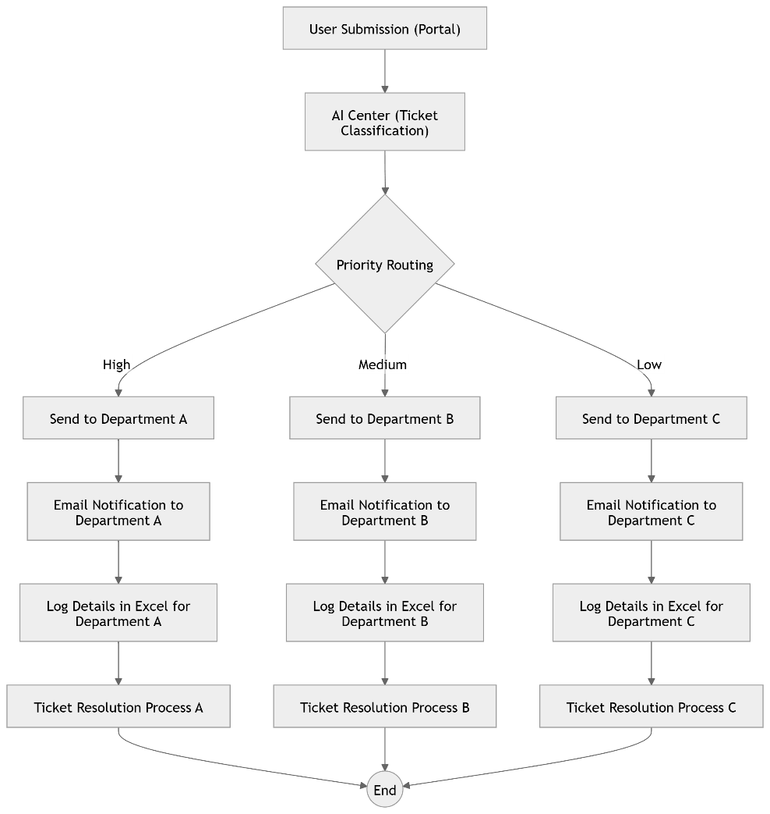

Fig.1 Flow diagram

## 3.2 ARCHITECTURE DIAGRAM

The **Architecture Diagram** outlines the flow of the support ticket system, starting with users submitting tickets via a portal or email. The AI model processes and classifies the tickets based on issue type and priority. UiPath automation then routes the tickets to the appropriate department and sends email notifications. Ticket details are logged in Excel for tracking, and departments resolve the issues and update the ticket status. This architecture ensures an efficient, automated ticket management system.

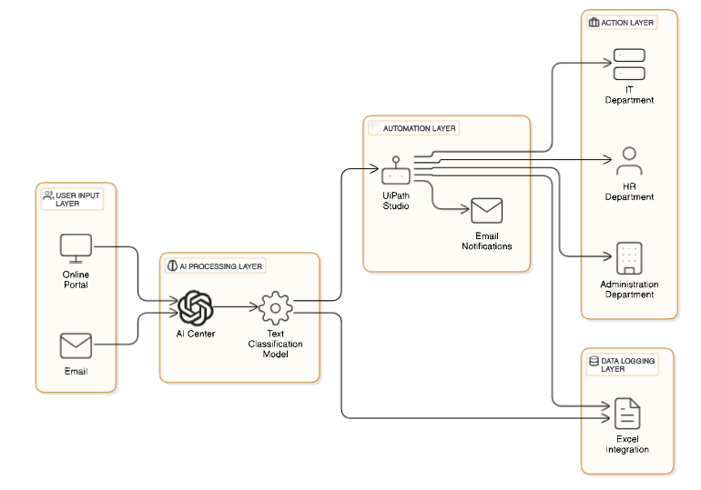

Fig.2 Architecture Diagram

## 3.3 SEQUENCE DIAGRAM

The **Sequence Diagram** shows how a user submits a ticket, which is then classified and prioritized by the AI model. UiPath automation routes the ticket to the appropriate department, and an email notification is sent. The ticket details are logged in Excel, and the department resolves the issue, updating the ticket status to closed. This sequence ensures efficient ticket processing and resolution.

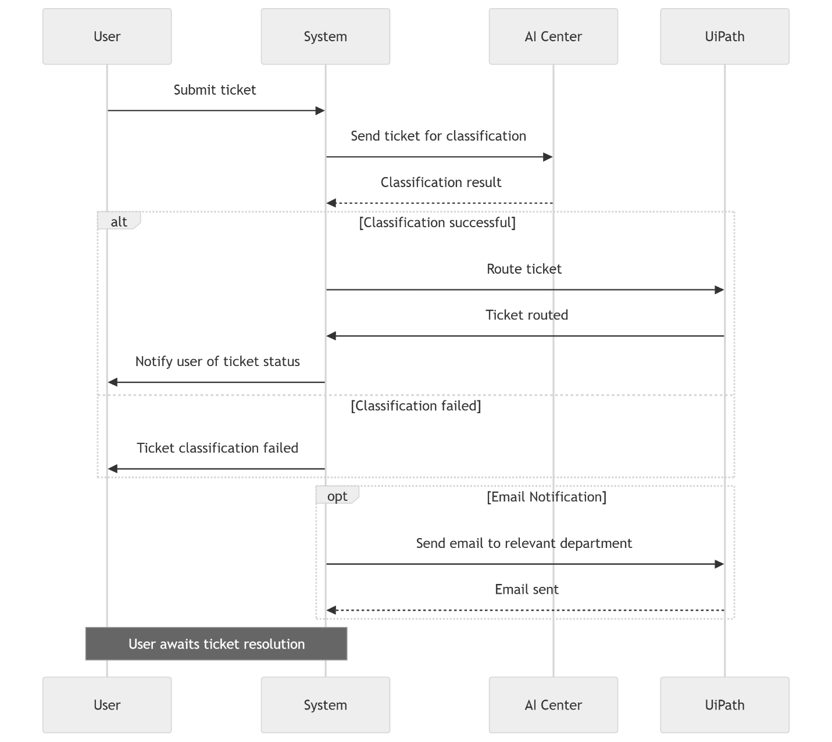

Fig.3 Sequence diagram

**CHAPTER IV**

# PROJECT DESCRIPTION

## 4.1 MODULE DESCRIPTION

### 4.1.1 TICKET SUBMISSION MODULE

This module allows users (students, faculty, or staff) to submit support tickets through a web portal or email. It collects the ticket’s details, including the issue description and user information.

**4.1.2 AI CLASSIFICATION AND PRIORITIZATION MODULE**

The AI model analyzes the submitted tickets, classifies the issues (e.g., IT, administrative, academic), and assigns a priority level (High, Medium, Low) based on predefined criteria.

## 4.1.3 TICKET ROUTING AND AUTOMATION MODULE

Using UiPath Studio, this module automates the process of routing tickets to the appropriate department (IT, HR, Admin) based on classification and priority. It ensures the right department receives the ticket in a timely manner.

**4.1.4 EMAIL NOTIFICATION MODULE**

Once tickets are routed, this module sends automated email notifications to the relevant department, informing them of the new ticket and providing all necessary details for resolution.

**4.1.5 TICKET RESOLUTION MODULE**

The respective departments handle and resolve the tickets based on their priority, updating the status as "resolved" or "pending" once the issue is addressed.

**CHAPTER V**

**PROJECT OVERVIEW**

**5.1 IMPLEMENTATION**

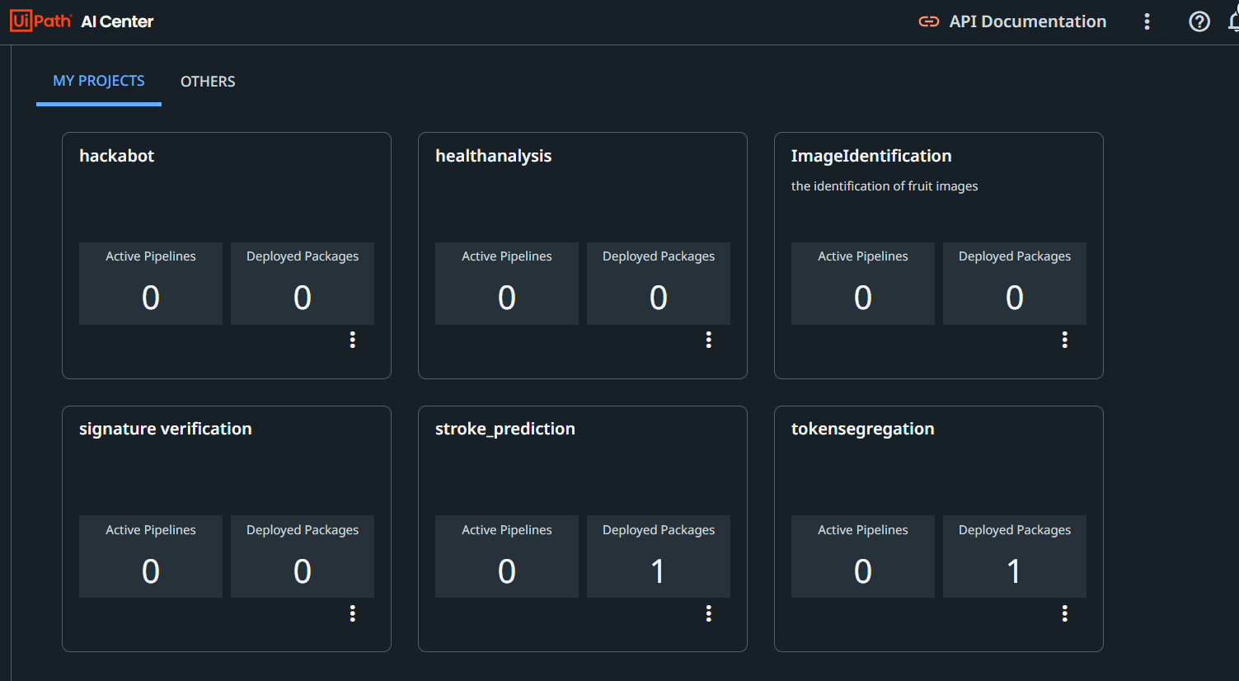

Fig.4 AI CENTER

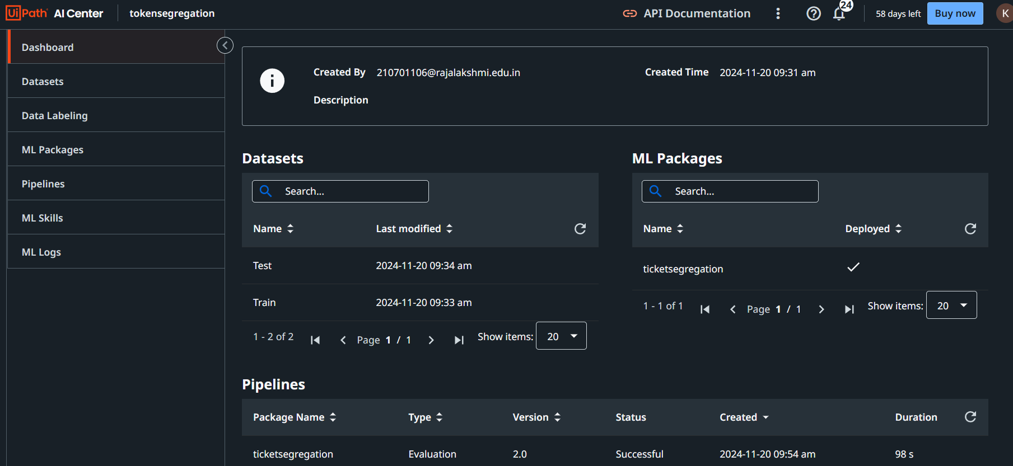

Fig.5 Ml skill creation

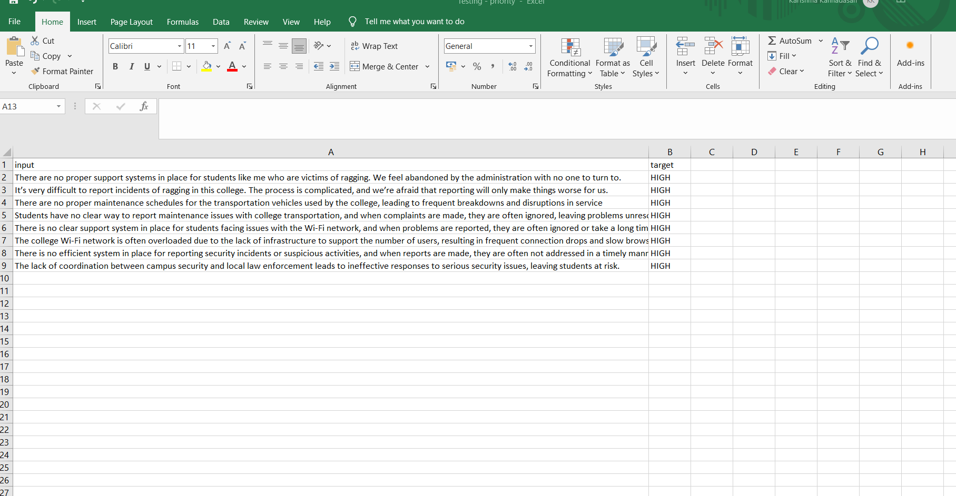

Fig.6 Train data

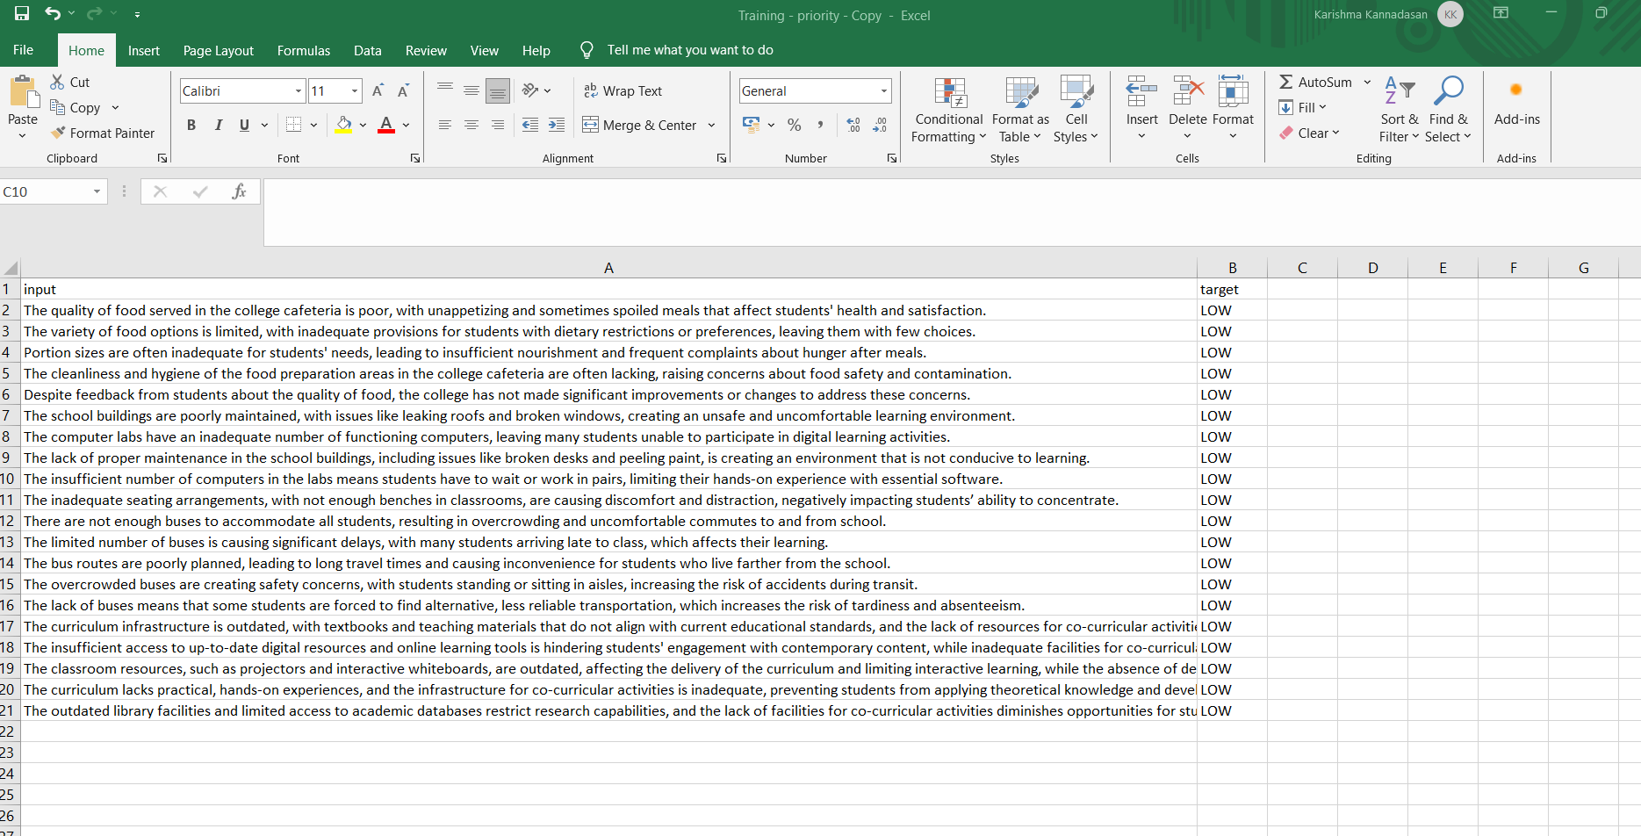

Fig.7 Test data

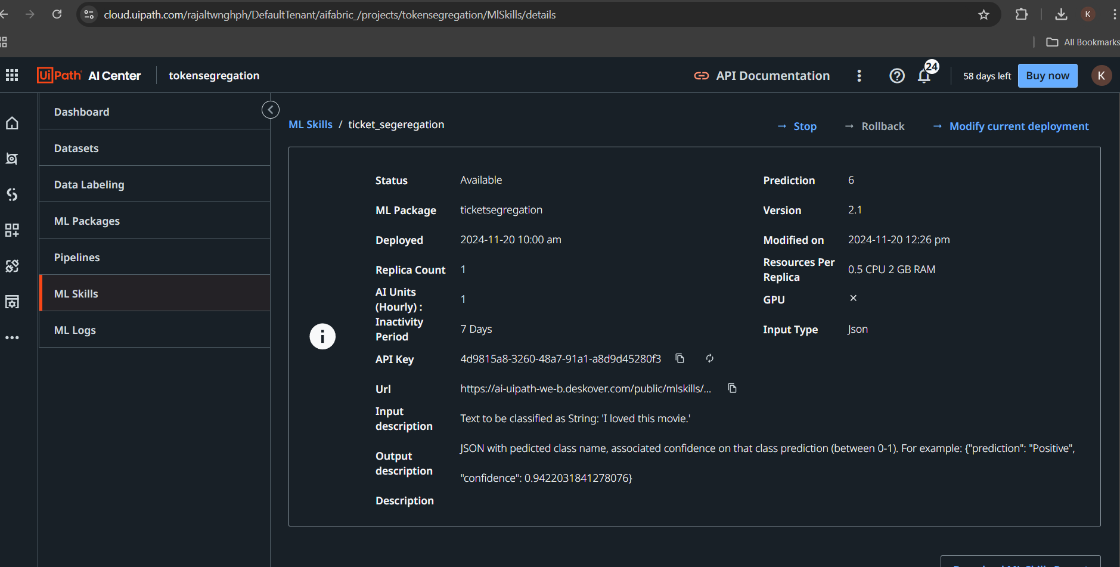

Fig.8 ML Skill API Key

**.**

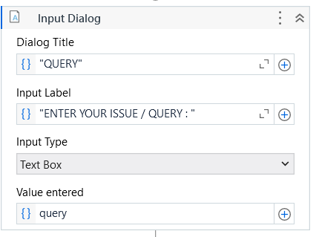

Fig.9 input dialogues

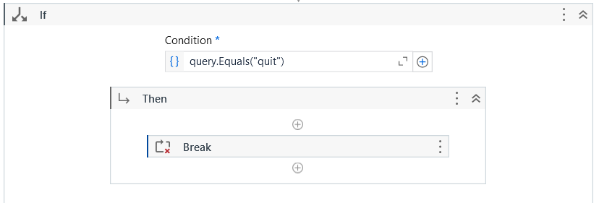

Fig.10 if Condition

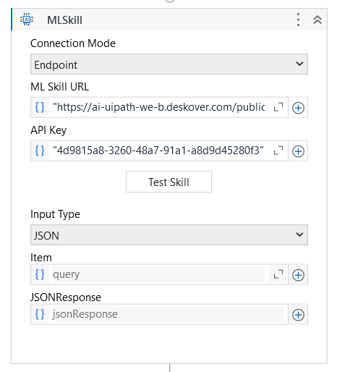

Fig.11 ML Skill in Uipath

**.**

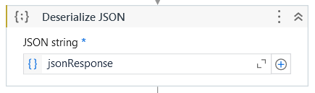

Fig.12 Deserialize Json

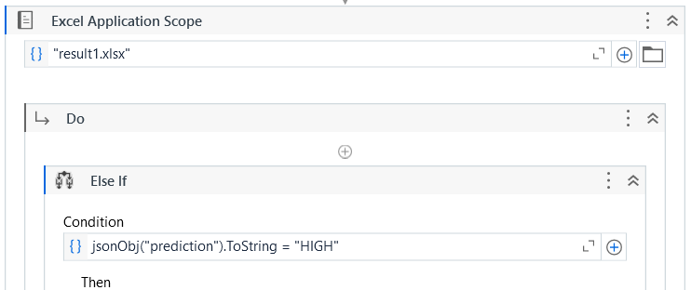

Fig13 Excel application Scope

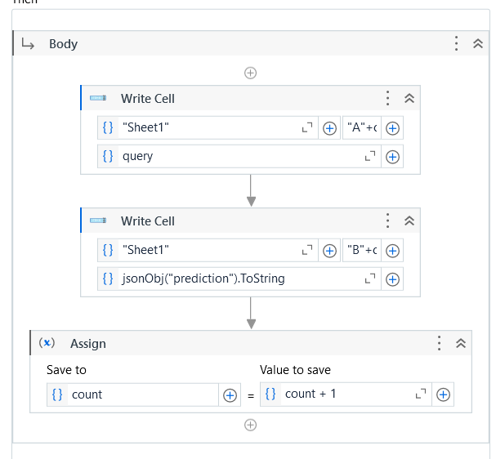

Fig.14 Excel automation

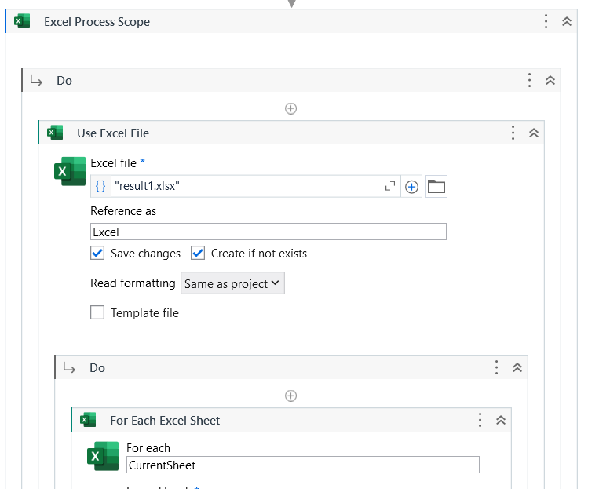

Fig.15 Sending mail through Excel Process

**5.2 OUTPUT SCREENSHOT**

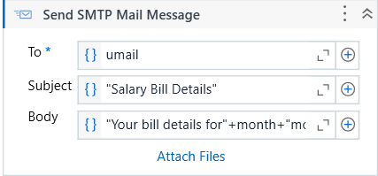

Fig.16 SMTP message activity

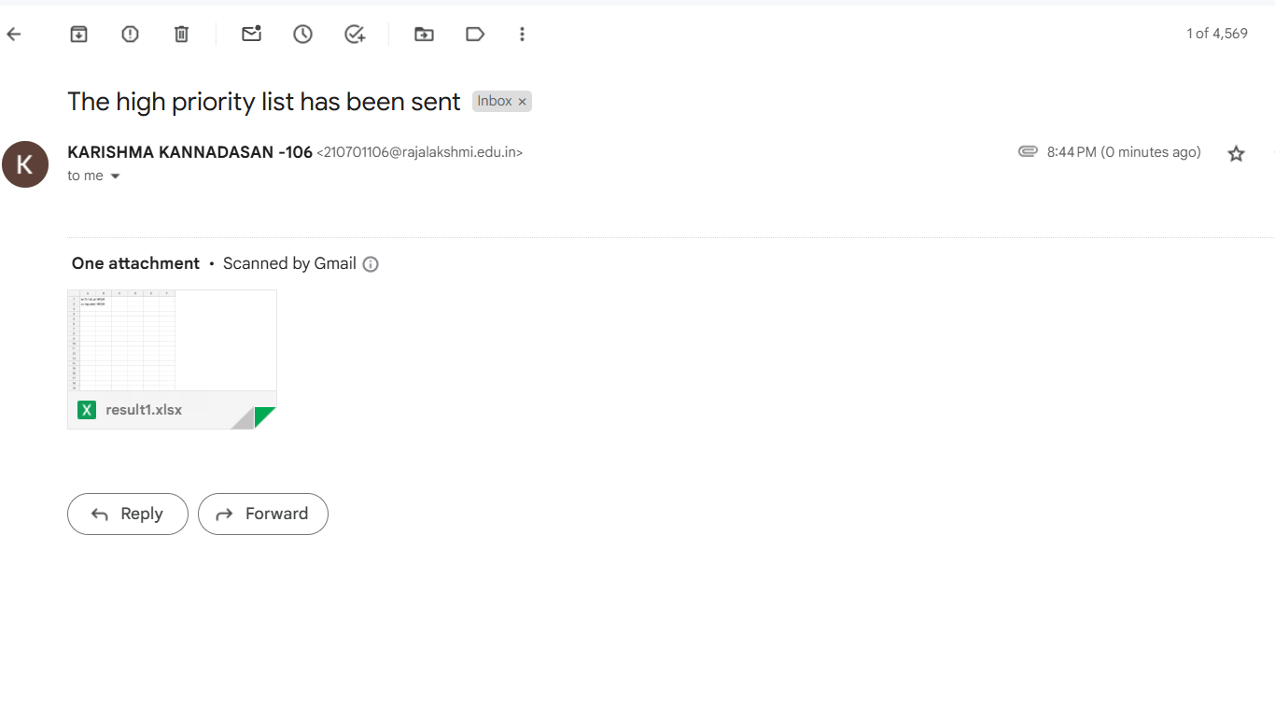

Fig.17 EMAIL

**CHAPTER VI**

**CONCLUSION & FUTURE ENHANCEMENTS**

**6.1 CONCLUSION**

The AI-powered support ticket management system effectively addresses the challenges faced by educational institutions in handling support tickets. By integrating Artificial Intelligence for ticket classification and prioritization, and using Robotic Process Automation (RPA) for routing and notification, the system streamlines the ticket handling process. This automation reduces manual effort, minimizes errors, and improves the response time for resolving issues. The integration of Excel for data logging ensures that ticket data is recorded for analysis and reporting, providing insights into system performance. Overall, the system enhances operational efficiency, improves user satisfaction, and ensures timely resolution of support tickets. The automation of routine tasks helps departments focus on resolving issues without delays, leading to a more organized and effective support process.

**6.2 FUTURE ENHANCEMENT**

Future enhancements to the AI-powered support ticket management system include integrating advanced AI and machine learning for improved ticket classification, and connecting with other institutional systems like LMS or SIS for automatic ticket generation. Real-time monitoring and alerts can be added to track ticket progress and ensure timely resolution. A self-service portal could allow users to solve simple issues independently, reducing ticket volume. Additionally, a mobile app could provide users and departments with on-the-go access, while automated ticket escalation could address critical unresolved tickets. Advanced reporting and multilingual support would further enhance system usability and accessibility, making it more efficient and adaptable to diverse needs.

**CHAPTER VII**

**REFERENCES**

1. <https://forum.uipath.com/>
2. [https://docs.uipath.com/orchestrator/standalone/2023.4/us](https://docs.uipath.com/orchestrator/standalone/2023.4/user-guide/introduction)
3. <https://docs.uipath.com/activities/other/latest/productivity/send-mail/>

4. [https://docs.uipath.com/studiox/standalone/2023.10/user- guide/introduction](https://docs.uipath.com/studiox/standalone/2023.10/user-%20%20%20%20guide/introduction)

**APPENDIX**







